|  |
| --- |
| news +++ PCIM  Nuremberg, 06 – 08 May 2025 |
| Ein Bild, das Schrift, Logo, Grafiken, Text enthält.  Automatisch generierte Beschreibung |

## PCIM Conference 2025: Now Calling for Papers!

Stuttgart, 24 July 2024. Starting now, experts from the realms of business and academia can submit their abstracts on a wide range of topics in power electronics for a chance to speak at the PCIM Conference 2025. This call for papers will be open until 15 October 2024.

The PCIM Conference gives authors of first-time publications the extraordinary opportunity to present their work to an international audience of more than 900 representatives from the business and scientific sides of power electronics. All those accepted will have their articles published in the PCIM Conference proceedings and renowned databases like IEEE Xplore, IET Inspec Direct, Knovel, and Scopus.

In addition, presenters at the PCIM Conference will benefit from the immediate feedback they receive from both the industry and the academic world – and make a number of valuable contacts in the power electronics community in the process. “The PCIM Expo & Conference is a great place where academia and industry meet,” affirms Adriana Campos, a power electronics engineer in R&D at the SuperGrid Institute who presented at the 2024 PCIM Conference. “As a speaker, you can share your results with the community to get feedback for further research. It’s also an outstanding opportunity to make new contacts and meet potential partners.”

### Choose from an array of ways to present

The PCIM Conference offers a variety of options when it comes to presenting, as well: First, there are the 20-minute talks on the conference stages at NCC Mitte. You can also choose a poster presentation, which will enable you to interact directly with other attendees. Finally, the event is once again offering the option to submit abstracts for half-day seminars. Scheduled to be held on the two days leading up to the PCIM Expo & Conference, this format makes it possible to delve into the details of special topics in the context of small groups.

### PCIM Conference Advisory Board to evaluate submissions

All the abstracts submitted will be assessed based on their currentness, relevance, quality, information value, and other criteria by the PCIM Conference Advisory Board, which is chaired by Prof. Leo Lorenz.

### Accolades and financial support

This year’s best submissions will be recognized in five categories by the Best Paper Award, the Young Engineer Award, and the Young Researcher Award. Besides enjoying their time in the spotlight at the event, the winners will be announced through various channels and will each receive a €1,000 prize.

The PCIM Conference will also provide a €500 travel subsidy to international students who wish to attend. Those interested should be full-time students in the field of power electronics and willing to make an in-person presentation in Nuremberg.

The world’s leading event in the power electronics community, the PCIM Expo & Conference combines a scientific convention with a practically oriented trade fair, resulting in a unique and incomparable platform. In 2024, the event welcomed an impressive 637 exhibiting companies, 18,102 visitors, and 952 conference participants from the realms of science and industry.

For all the information you need on the call for papers, please visit pcim.mesago.com/callforpapers.

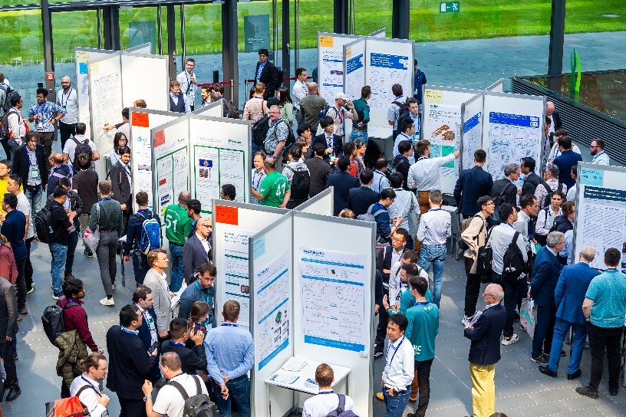

Mesago Messe Frankfurt GmbH / Arturo Rivas Gonzalez

PCIM

International exhibition and conference for Power Electronics, Intelligent Motion, Renewable Energy and Energy Management

The PCIM will be held from 06 - 08 May 2025.

#### Press information and photographic material:

[Press - PCIM](https://pcim.mesago.com/nuernberg/en/press.html)

#### Links to websites:

[PCIM – the international event in power electronics](https://pcim.mesago.com/events/en.html)

<https://twitter.com/pcimeurope>  
[https://www.facebook.com/pcimeurope](https://www.facebook.com/pcimeurope/)/  
<https://www.linkedin.com/showcase/pcim-europe/>

|  |
| --- |
|  |
| Your contact:  Lisette Hausser Phone: +49 711 61946-85 Lisette.hausser@mesago.com  Mesago Messe Frankfurt GmbH Rotebuehlstraße 83 -85 70178 Stuttgart Germany [www.mesago.com](https://corporate.mesago.com/events/en.html) |

#### Background information on Mesago Messe Frankfurt GmbH

Mesago, founded in 1982 and located in Stuttgart, specializes in exhibitions and conferences on various topics of technology. The company belongs to the Messe Frankfurt Group. Mesago operates internationally and is not tied to a specific venue. With around 160 members of staff Mesago organizes events for the benefit of more than 3,300 exhibitors and over 110,000 trade visitors, conference delegates and speakers from all over the world. Numerous trade associations, publishing houses, scientific institutes and universities work with Mesago closely as advisers, co-organizers and partners. ([mesago.com](https://corporate.mesago.com/events/en.html))

#### Background information on Messe Frankfurt

[www.messefrankfurt.com/background-information](http://www.messefrankfurt.com/background-information)

#### Sustainability at Messe Frankfurt

[www.messefrankfurt.com/sustainability-information](https://www.messefrankfurt.com/frankfurt/en/press/boilerplate.html#sustainability)