News +++ PCIM


First-ever PCIM Asia New Delhi Conference proves to be a rousing success in 2025

Stuttgart, 10 December 2025. Under the theme "Agent of Change", the PCIM – already known as the world's leading platform for power electronics – held its first conference in India this year. The Dr. Ambedkar International Conference and Exhibition Centre in New Delhi was the place to be on 9 – 10 December, with an impressive audience of industry experts taking in presentations by renowned companies in power electronics along with a targeted overview of future-oriented investment and expansion opportunities.
The PCIM Asia New Delhi Conference presented itself as a force driving technological progress in the region, aiming to create a forward-thinking platform that will foster strategic partnerships and promote collaboration among major players in industry, research, and politics.
"PCIM Asia New Delhi is more than a conference; it’s a catalyst for technological change. Our goal is to establish a platform that networks knowledge, promotes innovation, and helps shape the next era of power electronics in India," declares Lisette Hausser, Vice President of PCIM at Mesago Messe Frankfurt GmbH.
India’s Ministry of Electronics and Information Technology also recognizes the particular relevance of PCIM’s new event in Asia:
"Power electronics plays a decisive role in electrification and increasing energy efficiency. It forms the backbone of India's rapidly developing infrastructure – from renewable energies, power grids, and electromobility to rail transport and data centers. I am confident that the PCIM Asia New Delhi Conference will further accelerate progress in this area and strengthen the entire electronics ecosystem," says Ministry Secretary Shri S. Krishnan.
With over 520 participants, more than 120 speakers, and over 75 presentations, the Indian edition of the PCIM Conference also featured professional exchange at the highest level. Current research results and technical innovations in the field of power electronics were explained in detail, providing valuable impetus for the industry’s further development. In addition, illustrative poster presentations offered insights into pioneering projects and the results they have already achieved.
At the center of the event, however, was naturally on the conference, with the accompanying expo featuring a total of 50 exhibitors showing off their latest products and applications. Well-known companies such as Mitsubishi Electric, Infineon, and Rohm were on hand in New Delhi to experience the dynamic Indian market for power electronics first-hand.
The successful premiere of the PCIM Asia New Delhi Conference has now set the stage for further inspiring events focused on future-oriented technologies and strategic exchange, which are sure to continue driving the development of India’s power electronics industry.
Further information on the PCIM Asia New Delhi is available at www.pcim.in.

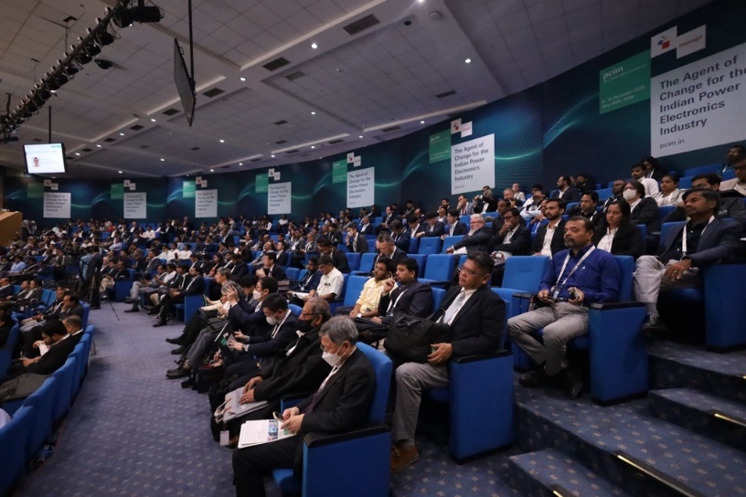
Messe Frankfurt India
PCIM – Hub for Power Electronics
The central platform for power electronics, intelligent drive technology, renewable energies, and energy management
The 2026 PCIM Expo & Conference will take place in Nuremberg from 9–11 June.

Press information and photographic material:
Press - PCIM Europe

Links to websites:
PCIM Europe – the international event in power electronics https://www.facebook.com/pcimeurope/
https://www.linkedin.com/showcase/pcim-europe/

Your contact:
Lisette Hausser
Phone: +49 711 61946-85
lisette.hausser@mesago.com
Mesago Messe Frankfurt GmbH
Rotebühlstrasse 83–85
70178 Stuttgart
www.mesago.com

Background information on Mesago Messe Frankfurt GmbH
Since 1982, Mesago Messe Frankfurt GmbH has specialized in creating B2B formats for specific technology topics. Having originally emerged from the trade fair and congress sector, the company now offers much more than internationally established technology events. Thanks to the consistent development of its portfolio, Mesago connects leading players worldwide through innovative platforms in the form of industry-specific technology hubs, available 24/7, 365 days a year. Alongside traditional expos and conferences, these hubs comprise digital events, in-depth knowledge formats, and comprehensive services that are tailored to the specific requirements of individual industries.
These hubs create a dynamic space for a timely exchange of information and technological innovation, providing a year-round flow of content. With a view to the ever-changing needs of trade communities, Mesago creates ideal conditions through its forward-looking formats, primarily to further develop an even more efficient global network and to ensure that it is always up to date with the latest developments. This is true to the company's motto: 'Driving technologies by connecting bright minds'.
As part of the Messe Frankfurt Group, Mesago employs around 170 people at its headquarters in Stuttgart, Germany. (mesago.com)

Background information on Messe Frankfurt
www.messefrankfurt.com/background-information

Sustainability at Messe Frankfurt
www.messefrankfurt.com/sustainability-information

