News +++ PCIM
Nuremberg, 9–11 June 2026
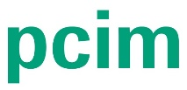

PCIM – Hub for Power Electronics promotes knowledge transfer and international networking all year round
Stuttgart, 7 October 2025. With the PCIM – Hub for Power Electronics, PCIM has been expanding its offerings beyond its established trade fair and conference since last year. The hub brings together specialist knowledge, events, and digital formats to promote the exchange of expertise, innovations, and international contacts in power electronics throughout the year.
The industry is under a great deal of pressure to innovate. As a result, topics such as electromobility, the energy transition, and intelligent drive systems have to continue to evolve. The PCIM – Hub for Power Electronics addresses this need by offering constant access to current content from industry and research. The aim is to present technological developments transparently, provide orientation, and systematically promote the transfer of knowledge within the industry. “With the PCIM – Hub for Power Electronics, we’re creating a platform that continuously connects industry, science, and international markets – digitally, in person, and throughout the year,” explains Lisette Hausser, Vice President of PCIM. “For a key technology like power electronics, it serves as a central location for professional exchange and fresh impetus.”
At the heart of the hub is the PCIM Expo & Conference in Nuremberg. Since 1979, this event has brought together international specialists and managers to present and discuss developments in power electronics, intelligent drive technology, renewable energies, and energy management. At the same time, the growing Indian market for power electronics is opening up new opportunities: In 2025, PCIM Asia New Delhi will take place for the first time as a conference with an accompanying trade fair.
PCIM is also expanding its range of information and offering the power electronics industry a valuable platform for knowledge transfer and professional orientation with its new insight formats. These include PCIM Magazine (whose latest issue went online on 17 September), the PCIM News Platform, the PCIM Directory, and PCIM Industry News. These formats provide well-founded specialist articles, exclusive interviews, and in-depth market analyses along the entire value chain.
In an environment characterized by rapid technological change and high pressure to innovate, these media formats not only provide orientation, but also deepen the community’s specialist understanding of the topics covered. They therefore contribute to the faster and more targeted dissemination of relevant knowledge – a decisive factor for progress in the industry.
The new formats focus in particular on the interplay between business and science. The academic world also plays an important part in the PCIM formats with contributions from the realms of research and teaching. The integration of scientific findings into industrial practice promotes innovation and strengthens the competitiveness of the power electronics industry. This interdisciplinary exchange is a central component of the PCIM – Hub for Power Electronics and underscores how the event functions as a bridge between theory and application.
With its expanded media portfolio, PCIM is positioning itself as the leading hub for power electronics – and as a driving force for the future of the industry.
Another important aspect is career development: The increasing demand for qualified specialists and performance-oriented young talent poses major challenges for the power electronics industry. The PCIM Career Board – a year-round, globally available job portal that focuses specifically on power electronics – was established specifically to address this shortage of skilled workers. It connects companies with qualified specialists and young talent while raising awareness of career opportunities in this innovation-driven industry.

With formats such as the German-language PCIM After-Work Events and the international PCIM Asia events in Shenzhen, Shanghai and, for the first time, New Delhi, PCIM offers additional opportunities for personal exchange. These gatherings strengthen global networking and promote access to international markets.

As the Hub for Power Electronics, PCIM unites the global power electronics community on a central platform and promotes the exchange of expertise, innovations, and career opportunities to actively shape the future of the industry.

Important dates at a glance
- December 2025: Publication of the next digital issue of PCIM Magazine
- 20 November 2025: PCIM After-Work Event in Böblingen, Germany
- 9–10 December 2025: PCIM Asia comes to New Delhi, India, for the first time
- 9–11 June 2026: PCIM Expo & Conference in Nuremberg, Germany

Further information is available on the PCIM website.

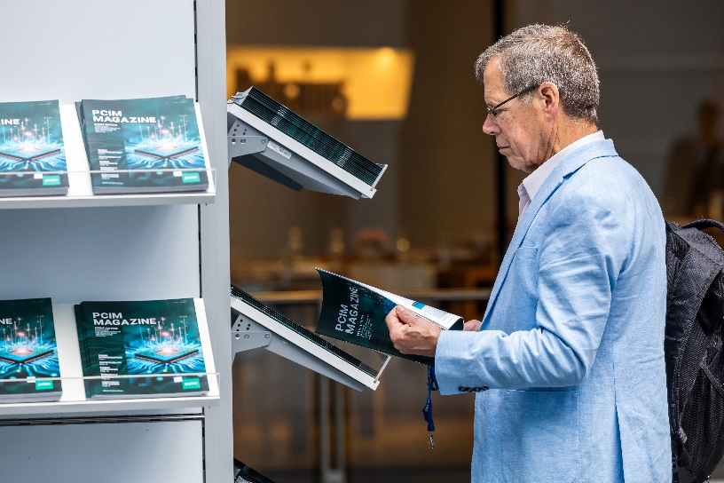
PCIM 2025. Copyright: Mesago Messe Frankfurt GmbH / Arturo Rivas Gonzalez
PCIM – Hub for Power Electronics
Year-round offerings on the latest trends and developments in the power electronics industry
The PCIM Europe will be held from 09 - 11 May 2026.

Press information and photographic material:
Press – PCIM

Links to websites:
PCIM – Hub for Power Electronics
https://www.facebook.com/pcimeurope/
https://www.linkedin.com/showcase/pcim-europe/

Your contact:
Lisette Hausser
Phone: +49 711 61946-85
lisette.hausser@mesago.com
Mesago Messe Frankfurt GmbH
Rotebühlstrasse 83–85
70178 Stuttgart
www.mesago.com

Background information on Mesago Messe Frankfurt GmbH
Mesago, founded in 1982 and located in Stuttgart, specializes in exhibitions and conferences on various topics of technology. The company belongs to the Messe Frankfurt Group. Mesago operates internationally and is not tied to a specific venue. With around 160 members of staff Mesago organizes events for the benefit of more than 3,300 exhibitors and over 110,000 trade visitors, conference delegates and speakers from all over the world. Numerous trade associations, publishing houses, scientific institutes and universities work with Mesago closely as advisers, co-organizers and partners. (mesago.com)

Background information on Messe Frankfurt
www.messefrankfurt.com/background-information

Sustainability at Messe Frankfurt
www.messefrankfurt.com/sustainability-information

