News +++ PCIM
Nuremberg, 9–11 June 2026
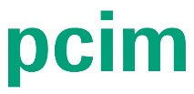

PCIM 2026 a Hotbed of Inspiration: AI a Key Driver in the Power Electronics Industry
Stuttgart, 11 June 2026. Following the culmination of the three-day PCIM Expo & Conference 2026, the international event for power electronics has once again proved itself a highlight in the industry calendar. From 9 to 11 June in Nuremberg, the expo brought the global community together and provided fresh inspiration for the future of the industry. This year, focus centered around artificial intelligence as both a development tool and a growth engine for power electronics.
With 650 exhibitors from 27 countries, more than 120 first-time exhibitors, and more than 60 percent of visitors traveling from outside of Germany, the PCIM once again proved to be a dynamic gathering for companies across the entire power electronics value chain.
“For us, the PCIM Expo is one of the most important platforms worldwide, as it is uniquely and consistently focused on power electronics like no other exhibition. This dedicated thematic focus enables a highly qualified exchange among experts and an in-depth exploration of the industry’s current topics. The resulting depth of content and technical quality makes the PCIM an outstanding and indispensable event for us“, comments Jörg Schulze, Director, Fraunhofer IISB.
James Willford, Head of Business Development at Semikron Danfoss added: “The PCIM is power electronics! For our company, it is simply the most significant event worldwide. I would also say that this event shapes the future of power electronics: it arms the engineers and business leaders of today with the building blocks that enable the power electronics systems of tomorrow”, states James Willford, Head of Business Development at Semikron Danfoss.
The impressions of organizer Mesago Messe Frankfurt were similarly favorable:
As Lisette Hausser, Vice President PCIM Expo & Conference, explains: “The PCIM 2026 once again demonstrated the vibrancy and innovation inherent in the power electronics industry. The response to the new formats and focus topics, especially AI and data centers, was overwhelmingly positive. This strengthens our resolve to keep improving the PCIM in line with the needs of the industry.”

Record figures for the PCIM Conference
For the first time, the conference, which runs in parallel to the expo, featured 500 presentations and poster sessions on the latest research topics, offering 960 attendees in-depth insights into the world of power electronics. AI was also the focus topic of the conference, encompassing a keynote speech “AI Meets Power Electronics: Are we there yet?” as well as special sessions dedicated to AI applications and data center technologies.
Featuring numerous first-time publications from both industry and academia, the PCIM Conference again proved itself a central platform for knowledge sharing within the sector. Ahead of the expo, the PCIM Seminars had already delivered practice-based expertise covering the entire technological spectrum:
“The PCIM Conference offers a unique overview of how the various subfields of power electronics interact. It is an excellent platform to present ideas, gain valuable feedback, and explore the latest developments from both research and industry. This makes it, in my view, the leading European conference at the intersection of academia and industry”, comments Matthew Appleby, University of Bristol, Best Paper Award Winner and Speaker at the PCIM Conference 2026.
The audience was equally impressed:
“For me, the highlight was the real-world relevance of the presentations. Much of the content was directly applicable to current challenges in my day-to-day work,” said Dr. Sinan Zengin, Conference attendee, GE Grid GmbH.

New stage enjoys a successful premiere
This year, a new presentation stage, the AI & Data Centers Stage, joined the Exhibitor, Technology, and E-Mobility & Energy Storage stages at the conference. The motivation behind this was to shine a light on two of the biggest recent trends in power electronics.
“The new AI & Data Centers Stage was one of my personal highlights at this year’s PCIM,” commented Keinosuke Muraji, ROHM Semiconductor. “It clearly demonstrated the growing importance of artificial intelligence for the power electronics industry, and what applications are already possible today.”
All stages offered attendees a wide range of specialist talks and discussion formats, delivering practical insights into current technological advancements, innovative solutions, and real-world applications. With their distinct focus topics, the individual stages provided a structured overview of the latest industry trends.

Looking ahead
A detailed analysis of the event, including facts and figures, is expected to be available in July.

365 days of PCIM: Knowledge and networking throughout the year
The PCIM – Hub for Power Electronics is the year-round platform for knowledge transfer beyond the live event. Bringing together a variety of digital formats and networking opportunities, the PCIM hub offers the international community continuous access to the latest trends, technologies, and solutions. Formats such as the PCIM Magazine, PCIM After Work Events, and the PCIM News Platform facilitate international exchange and help to drive innovation within the sector. More information about the PCIM – Hub for Power Electronics is available online.

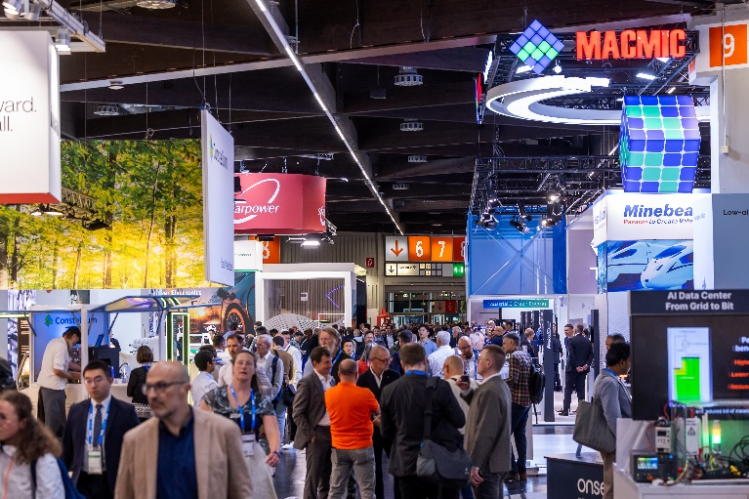
Copyright: Mesago Messe Frankfurt GmbH / Arturo Rivas Gonzalez
PCIM
International Exhibition and Conference for Power Electronics, Intelligent Motion, Renewable Energy, and Energy Management
Next year’s PCIM runs from 11–13 May 2027.

Press information and photo material:
Press – PCIM

Links to websites:
PCIM – the event for power electronics
https://www.facebook.com/pcim/
https://www.linkedin.com/showcase/pcim/

Your contact:
Lisette Hausser
Phone: +49 711 61946-85
Lisette.Hausser@mesago.com
Mesago Messe Frankfurt GmbH
Rotebuehlstraße 83 -85
70178 Stuttgart
Germany
www.mesago.com

Background information on Mesago Messe Frankfurt GmbH
Since 1982, Mesago Messe Frankfurt GmbH has specialized in creating B2B formats for specific technology topics. Having originally emerged from the trade fair and congress sector, the company now offers much more than internationally established technology events. Thanks to the consistent development of its portfolio, Mesago connects leading players worldwide through innovative platforms in the form of industry-specific technology hubs, available 24/7, 365 days a year. Alongside traditional expos and conferences, these hubs comprise digital events, in-depth knowledge formats, and comprehensive services that are tailored to the specific requirements of individual industries.
These hubs create a dynamic space for a timely exchange of information and technological innovation, providing a year-round flow of content. With a view to the ever-changing needs of trade communities, Mesago creates ideal conditions through its forward-looking formats, primarily to further develop an even more efficient global network and to ensure that it is always up to date with the latest developments. This is true to the company's motto: 'Connecting bright minds'.
As part of the Messe Frankfurt Group, Mesago employs around 170 people at its headquarters in Stuttgart, Germany. (mesago.com)

Background information on Messe Frankfurt
www.messefrankfurt.com/background-information

Sustainability at Messe Frankfurt
www.messefrankfurt.com/sustainability-information

