news +++ PCIM
Nuremberg, 11 - 13 May 2027


PCIM Asia Shenzhen 2026: International Power Electronics Community Comes Together in Southern China
Stuttgart, 31 August 2026. From August 26 to 28, the PCIM Asia Shenzhen 2026 brought experts from industry, science, and research together at the Shenzhen World Exhibition & Convention Center for an event that reaffirmed its role as one of Asia's leading platforms for power electronics. With 30,000 sqm of exhibition space, 20,157 trade visitors, 271 exhibitors, and 131 expert presentations as part of the conference program, the event sent a strong message about the industry's innovative strength and dynamism.
"Shenzhen is one of the world's leading centers for technology and innovation. The high turnout of exhibitors, speakers, and trade visitors demonstrates that the PCIM Asia Shenzhen brings the right stakeholders together in the right place. The event accelerates the transfer of technological developments into real-world industrial applications while also creating opportunities for new business relationships," says Lisette Hausser, Vice President of PCIM.
Focus on trending technologies
The key topics focused on at this year's event included e-mobility, AI data centers, renewable energies, and smart energy, as well as modern power electronics solutions based on wide-bandgap semiconductors such as silicon carbide (SiC) and gallium nitride (GaN). Numerous domestic and international companies showcased their innovative products and solutions to the industry's current and future challenges.
Three new special exhibition areas proved particularly popular: the Industrial Chain Display Zone – Power Electronics for E-Mobility, the AI Data Center Power Ecosystem Zone, and the Renewable Energy & Smart Energy Zone. These were complemented by an extensive supporting program featuring a total of 192 forum presentations, specialist seminars, and product presentations.
Outstanding knowledge sharing
Another key element of the event was the conference program. Renowned experts from industry, research, and science discussed the current challenges and potential solutions in power electronics.
The combination of scientific expertise and industrial experience created ideal conditions for sustainable knowledge transfer and the emergence of new opportunities for collaboration.

Looking ahead to the PCIM Asia Shanghai 2027
After three days of in-depth discussions on the future of power electronics, attention is already turning to the next edition of the event. Due to its relocation in August 2027, it will be renamed as PCIM Asia Shanghai to reflect its new home city.
Further information on the PCIM Asia Shenzhen/Shanghai is available at www.pcimasia-shenzhen.cn.messefrankfurt.com.

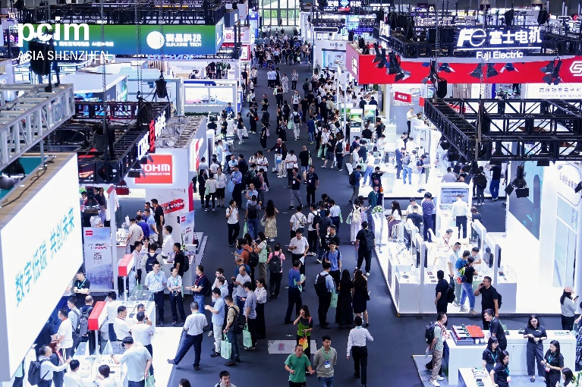
Copyright: Mesago Messe Frankfurt GmbH

PCIM Expo & Conference
International exhibition and conference for Power Electronics, Intelligent Motion, Renewable Energy and Energy Management
The next PCIM Expo & Conference will be held from 11 – 13 May 2027.

Press information and photographic material:
Press - PCIM

Links to websites:
PCIM – the international event in power electronics
https://www.facebook.com/pcim/
https://www.linkedin.com/showcase/pcim/

Your contact:
Lisette Hausser
Telefon: +49 711 61946-85
Lisette.Hausser@mesago.com
Mesago Messe Frankfurt GmbH
Rotebuehlstraße 83 -85
70178 Stuttgart
Germany
www.mesago.com

Background information on Mesago Messe Frankfurt GmbH
Since 1982, Mesago Messe Frankfurt GmbH has specialized in creating B2B formats for specific technology topics. Having originally emerged from the trade fair and congress sector, the company now offers much more than internationally established technology events. Thanks to the consistent development of its portfolio, Mesago connects leading players worldwide through innovative platforms in the form of industry-specific technology hubs, available 24/7, 365 days a year. Alongside traditional expos and conferences, these hubs comprise digital events, in-depth knowledge formats, and comprehensive services that are tailored to the specific requirements of individual industries.
These hubs create a dynamic space for a timely exchange of information and technological innovation, providing a year-round flow of content. With a view to the ever-changing needs of trade communities, Mesago creates ideal conditions through its forward-looking formats, primarily to further develop an even more efficient global network and to ensure that it is always up to date with the latest developments. This is true to the company's motto: 'Connecting bright minds'.
As part of the Messe Frankfurt Group, Mesago employs around 170 people at its headquarters in Stuttgart, Germany. (mesago.com)

Background information on Messe Frankfurt
www.messefrankfurt.com/background-information

Sustainability at Messe Frankfurt
www.messefrankfurt.com/sustainability-information

