news +++ PCIM
Nuremberg, 09 – 11 June 2026
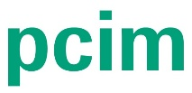

PCIM Executive Circle: New high-level forum for strategic dialogue in power electronics
Stuttgart, 28 May 2026. When the international power electronics industry gathers in Nuremberg for the PCIM Expo & Conference from June 9 to 11, 2026, the event will be about much more than just technologies and trends – it will be about the future of the industry. Starting on June 8, the new PCIM Executive Circle will bring together selected decision-makers in an exclusive setting to openly discuss strategic issues facing the industry and generate new ideas.
“Power electronics is a key enabler for electric mobility, renewable energy, and AI infrastructure. With the PCIM Executive Circle, we are specifically expanding the PCIM to include a strategic forum for decision-makers – providing a space for open discussion, new perspectives, and ideas for the future of the industry,” states Lisette Hausser, Vice President of PCIM.
In an exclusive setting, the PCIM Executive Circle brings together international decision-makers from across the entire power electronics value chain. This business-oriented format is deliberately designed not for academic exchange, but to address strategic issues related to the market, transformation, and corporate development. Off-the-record guidelines, a participant-centered approach, and direct dialogue create a unique atmosphere for open discussions among peers.
The Executive Circle incorporates elements of an unconference: rather than a traditional stage program, the focus is on the participants. The content and discussions emerge from their perspectives, experiences, and current challenges. The limited number of participants creates the ideal setting for meaningful conversations and lasting connections.
The agenda combines keynote speeches, interactive roundtables, and targeted networking sessions. Following the opening, Ole Gerkensmeyer, Chief Strategy Officer at Nexperia, will deliver a keynote on geopolitical tensions and their impact on industrial partnerships. In parallel sessions, participants will discuss topics such as:
- Sustainability
- Innovative Materials
- AI-driven Research
- Data Centers
- Resilient Supply Chains
- Energy Transition
- Industry-Startup Partnerships
Experts such as Mahyar Koshravi (Nitride Global), Stefan Hain (onsemi), Milan Rosina (Yole Group), Jörg Schulze (Fraunhofer IISB), Tobias Keller (Hitachi Energy), Tanjeff Schadt (Strategy&), and Wolfgang Dengler (BayernKapital) will share their perspectives from the fields of industry, research, and innovation.
There will be sufficient time between sessions for one-on-one conversations and networking. The event will conclude with a get-together featuring food and drinks.
The PCIM Executive Circle not only offers participants professional and strategic value, but also the opportunity to forge new collaborations and partnerships, exchange ideas with like-minded individuals, and actively contribute their own ideas. At the same time, the format provides a space for inspiration, strategic reflection, and the further development of business objectives.
Those interested can now register for the exclusive PCIM Executive Circle: https://bit.ly/4ux7tZv
The PCIM Expo & Conference is the industry’s premier platform for groundbreaking product launches, innovations, and the latest research findings. With its unique combination of a scientific conference and a practice-oriented trade show, the 2025 event attracted a total of 685 exhibiting companies, 16,500 visitors, and over 800 conference participants from academia and industry. With a record 62% international participation, the event underscores its global relevance and is the leading international event for the power electronics community.

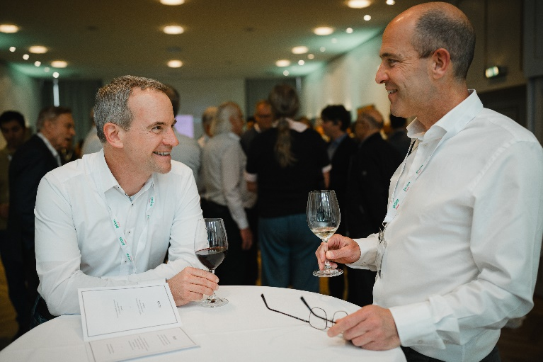
Copyright: Mesago Messe Frankfurt GmbH / Arturo Rivas Gonzalez
PCIM
International exhibition and conference for Power Electronics, Intelligent Motion, Renewable Energy and Energy Management
The PCIM will be held from 09 - 11 June 2026.

Press information and photographic material:
Press - PCIM

Links to websites:
PCIM – the international event in power electronics
https://www.facebook.com/pcim/
https://www.linkedin.com/showcase/pcim/

Your contact:
Lisette Hausser
Phone: +49 711 61946-85
Lisette.Hausser@mesago.com
Mesago Messe Frankfurt GmbH
Rotebuehlstraße 83 -85
70178 Stuttgart
Germany
www.mesago.com

Background information on Mesago Messe Frankfurt GmbH
Since 1982, Mesago Messe Frankfurt GmbH has specialized in creating B2B formats for specific technology topics. Having originally emerged from the trade fair and congress sector, the company now offers much more than internationally established technology events. Thanks to the consistent development of its portfolio, Mesago connects leading players worldwide through innovative platforms in the form of industry-specific technology hubs, available 24/7, 365 days a year. Alongside traditional expos and conferences, these hubs comprise digital events, in-depth knowledge formats, and comprehensive services that are tailored to the specific requirements of individual industries.
These hubs create a dynamic space for a timely exchange of information and technological innovation, providing a year-round flow of content. With a view to the ever-changing needs of trade communities, Mesago creates ideal conditions through its forward-looking formats, primarily to further develop an even more efficient global network and to ensure that it is always up to date with the latest developments. This is true to the company's motto: 'Connecting bright minds'.
As part of the Messe Frankfurt Group, Mesago employs around 170 people at its headquarters in Stuttgart, Germany. (mesago.com)

Background information on Messe Frankfurt
www.messefrankfurt.com/background-information

Sustainability at Messe Frankfurt
www.messefrankfurt.com/sustainability-information

