News +++ PCIM
Nuremberg, 9–11 June 2026


PCIM Expo & Conference 2026 puts AI in the spotlight
Stuttgart, 19 March 2026. From 9 to 11 June 2026, the leading international exhibition and conference for power electronics, the PCIM Expo & Conference, returns to Nuremberg, Germany. With over 650 exhibitors and a record-breaking 500+ presentations, this hub for the power electronics industry will offer a comprehensive program for trade visitors. With the new AI & Data Centers Stage, this year’s trade fair and conference program will focus on the topic of artificial intelligence and data centers for the first time.
The escalating energy needs of modern data centers are driving demand for high-performance, energy-efficient, and sustainable solutions. With the new AI & Data Centers Stage, the PCIM Expo 2026 places a distinct emphasis on two of the most important future trends in power electronics. The new stage brings together a wide range of expert presentations and best practices addressing the growing influence of artificial intelligence and the escalating energy demands of modern data centers.
“The AI & Data Centers Stage is our first venture into providing a central platform for in-depth industry knowledge and cutting-edge inspiration on the topic of artificial intelligence. Visitors to the PCIM Expo can look forward to learning about the latest developments – from AI-powered design and monitoring processes to innovative energy management and power supply systems for data centers,” explains Lisette Hausser, Vice President PCIM at Mesago Messe Frankfurt GmbH.
The AI & Data Centers presentation program will focus on the topics “AI for Power Electronics” and “Power Electronics for Data Centers.” A total of 40 presentations will take place on stage.
AI also takes center stage at the PCIM Conference
This year’s PCIM Conference will also focus on the topic of artificial intelligence with a keynote address and two special sessions:
- 10 June 2026:
  - Keynote: AI Meets Power Electronics: Are we there yet?
Uwe Drofenik (Vienna University of Technology)
  - Special session: Artificial Intelligence in Power Electronics
Ole Gerkensmeyer (Nexperia)
- 11 June 2026:
  - Special session: Power Continuity vs. Power Quality – AI Data Centers
Lorenzo Giuntini (ABB)
  - Oral session: Data Center DC-DC Converters
Klaus F. Hoffmann (Helmut Schmidt University)
Focused practical knowledge two days before the Expo
The PCIM Seminars, which take place on 7 and 8 June at the Arvena Park Hotel in Nuremberg, will give participants the chance to gain first-hand practical knowledge. They offer a unique setting for direct discussion of specialized topics along the entire power electronics value chain. This year, participants will get the opportunity to explore the topic of artificial intelligence in depth during two seminars:
- 7 June 2026:
AI-Enhanced Condition Monitoring and Control in Modern Power Electronics
Maher Al-Greer (Teesside University)
- 8 June 2026:
Magnetics for High Power in Artificial Intelligence and Modern Automotive Applications
Ionel “Dan” Jitaru (Rompower Energy Systems)
Presentation program offers insights into innovations, sustainability, and future trends in power electronics
In addition to the AI & Data Centers Stage, the extensive presentation program on the Technology, Exhibitor, and E-Mobility & Energy Storage stages will provide a concise overview of industry trends and challenges, while also discussing some of the latest technologies in action.
The Technology Stage will feature presentations and panel discussions on the latest research by leading universities and providers, with a special focus on SiC (silicon carbide) and GaN (gallium nitride) technologies.
The Exhibitor Stage will offer visitors in-depth insights into product innovations from exhibiting companies such as Rohm, Infineon, Nexperia, and Fuji.
The E-Mobility & Energy Storage Stage will focus on current and future developments in power electronics for use in electromobility and energy storage, taking into account different applications in electric, hybrid, and fuel cell vehicles, for example.

PCIM Expo 2026: facts and figures
With three months still to go, the world’s leading exhibition and conference for power electronics, intelligent motion, renewable energy, and energy management already has more than 650 registered exhibitors, over 60% from international companies. The products on show will cover the entire power electronics value chain, ranging from power semiconductors, test and measurement technologies, and automation solutions to materials for different fields of application, including the aviation industry.
This year’s exhibitors include industry leaders such as Mitsubishi, Onsemi, Sumida, and Toshiba. With more than 120 new exhibitors, the exhibition also promises an even wider, more diverse range of products. The participation of new companies from different nations encourages networking on a global level and promotes synergies that can accelerate the development of new technologies.
The companies taking part for the first time include established market leaders and innovative tech firms such as Allegro MicroSystems, Analog Devices, Iwatani, NHK Spring, and Moteon.

About the event
The PCIM Expo & Conference is the power electronics industry’s central platform for ground-breaking product premieres, innovations, and the latest research findings. With its unique combination of scientific convention and practically oriented trade fair, the event welcomed 685 exhibiting companies, 16,500 visitors, and more than 800 conference participants from the realms of science and industry in 2025. The PCIM Expo & Conference also drew a record 62% of its attendees from outside Germany last year, underscoring the global relevance of power electronics and reaffirming the PCIM’s position as the leading international event for the power electronics community.
For more information, please visit the homepage of the PCIM – Hub for Power Electronics.
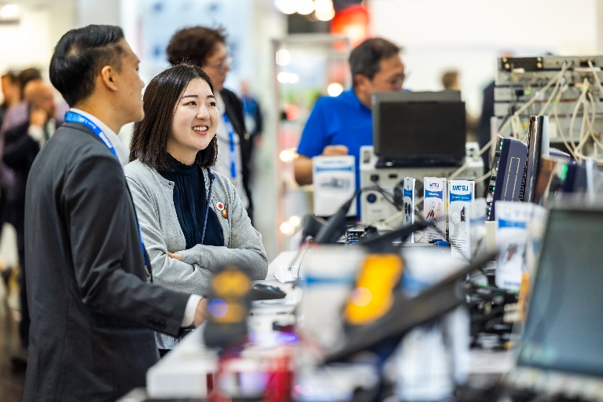
Copyright: Mesago Messe Frankfurt GmbH / Arturo Rivas Gonzalez

PCIM
International exhibition and conference for Power Electronics, Intelligent Motion, Renewable Energy and Energy Management
The PCIM will be held from 09 - 11 June 2026.
Press information and photographic material:
Press - PCIM
Links to websites:
PCIM – the international event in power electronics
https://www.facebook.com/pcimeurope/
https://www.linkedin.com/showcase/pcim-europe/

Your contact:
Lisette Hausser
Phone: +49 711 61946-85
Lisette.Hausser@mesago.com
Mesago Messe Frankfurt GmbH
Rotebuehlstraße 83 -85
70178 Stuttgart
Germany
www.mesago.com
Background information on Mesago Messe Frankfurt GmbH
Since 1982, Mesago Messe Frankfurt GmbH has specialized in creating B2B formats for specific technology topics. Having originally emerged from the trade fair and congress sector, the company now offers much more than internationally established technology events. Thanks to the consistent development of its portfolio, Mesago connects leading players worldwide through innovative platforms in the form of industry-specific technology hubs, available 24/7, 365 days a year. Alongside traditional expos and conferences, these hubs comprise digital events, in-depth knowledge formats, and comprehensive services that are tailored to the specific requirements of individual industries.
These hubs create a dynamic space for a timely exchange of information and technological innovation, providing a year-round flow of content. With a view to the ever-changing needs of trade communities, Mesago creates ideal conditions through its forward-looking formats, primarily to further develop an even more efficient global network and to ensure that it is always up to date with the latest developments. This is true to the company's motto: 'Connecting bright minds'.
As part of the Messe Frankfurt Group, Mesago employs around 170 people at its headquarters in Stuttgart, Germany. (mesago.com)
Background information on Messe Frankfurt
www.messefrankfurt.com/background-information
Sustainability at Messe Frankfurt
www.messefrankfurt.com/sustainability-information

