news +++ PCIM
Nuremberg, May 11–13, 2027
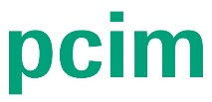

PCIM Expo & Conference 2027: Call for papers for conference and seminars now open
Stuttgart, July 15, 2026. Experts from the realms of industry and academia are now invited to submit their abstracts on current issues in power electronics for a chance to speak at the PCIM Conference 2027. The Conference takes place from May 11 to 13, 2027 in Nuremberg alongside the PCIM Expo. Contributions can also be submitted for the PCIM seminars scheduled for the two days before the main event. These sessions will concentrate on practice-related expertise and in-person discussions. The deadline for submitting papers is October 14, 2026.
The PCIM Expo & Conference is regarded as one of the leading international events in power electronics, with the 2027 edition focusing on current developments in power semiconductors, passive components, heat management solutions, energy storage and sensor technology as well as new materials and systems. The event will thus address the key trends and forward-looking issues in power electronics, providing authors with an ideal platform for presenting their research results – including initial public disclosures – to an international professional audience. All accepted authors will have their papers published in the PCIM Conference proceedings and established databases such as IEEE Xplore and Scopus.
Axel Wagret, Hardware Power Electronics Design Engineer at Airbus and winner of the Young Engineer Award 2026, highlights the benefits of participating in the PCIM Conference: “Being part of the conference program gives your work incredible visibility among top-tier specialists. But beyond that, the real value lies in the networking and exchange: the direct feedback you receive from both academia and industry is unmatched and can genuinely accelerate your research.”
Advisory Board acts as quality guarantor
The Conference Advisory Board, chaired by Prof. Dr. Leo Lorenz and Prof. Dr. Drazen Dujic, selects and assesses the papers submitted. A multi-level assessment process ensures that papers meet scientific quality standards and are relevant in terms of their practical application. This established approach plays a major role in ensuring the high level of expertise of the PCIM Conference.
"Every piece of work submitted helps shape the future of power electronics," explains Dujic, adding, "The PCIM Conference brings together the leading minds in power electronics, providing them with an international forum for their research results. Speakers also benefit from a unique network that drives innovation and opens up opportunities for new collaborations."
Wide-ranging presentation formats
The PCIM Conference boasts a broad scope of presentation formats that allows intensive high-level discussion of specialist topics:
- Presentations: 20-minute conference presentations on the stages of the conference rooms
- Poster sessions: Format that allows interaction between speakers and attendees in an exhibition hall
- Seminars: Half-day events in small groups on the two days before the PCIM Expo & Conference. These sessions allow in-depth dialog on specialist topics
Accolades and financial support
As in previous years, next year's event will feature the PCIM Conference Awards honoring outstanding submissions in the categories Best Paper Award, Young Engineer Award and Young Researcher Award. The awards recognize innovative contributions and fund technological developments and new creative ideas in the industry. Each one comes with a 1,000-euro prize.
Furthermore, the PCIM Conference supports international students with travel grants worth 600 euros each. The aim here is to enable talented young people to actively participate in the conference and to facilitate their integration into the industry's international community.
Major platform for power electronics
The PCIM Conference brings together international experts from industry and academia. In 2026 the number of presentations topped 500 for the first time, with the event attracting 960 conference attendees from all around the world. Sixty-two percent of visitors come from abroad, underlining the conference's global significance and its status as a major meeting place for those working in the industry.
Further information
If you are interested in submitting a paper, please do so by October 14, 2026. You can access all the information you require on topics, formats and how to submit a paper on the PCIM Expo & Conference website.
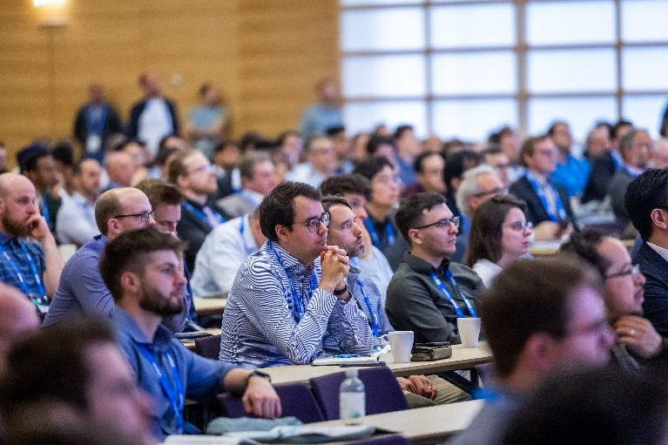
Copyright: Mesago Messe Frankfurt GmbH / Arturo Rivas Gonzalez

PCIM Expo & Conference
International Exhibition and Conference for Power Electronics, Intelligent Motion, Renewable Energy, and Energy Management
Next year’s PCIM runs from May 11–13, 2027.

Press information and photo material:
Press – PCIM

Links to websites:
PCIM – the event for power electronics
https://www.facebook.com/pcim/
https://www.linkedin.com/showcase/pcim/

Your contact:
Lisette Hausser
Phone: +49 711 61946-85
Lisette.Hausser@mesago.com
Mesago Messe Frankfurt GmbH
Rotebuehlstraße 83 -85
70178 Stuttgart
Germany
www.mesago.com

Background information on Mesago Messe Frankfurt GmbH
Since 1982, Mesago Messe Frankfurt GmbH has specialized in creating B2B formats for specific technology topics. Having originally emerged from the trade fair and congress sector, the company now offers much more than internationally established technology events. Thanks to the consistent development of its portfolio, Mesago connects leading players worldwide through innovative platforms in the form of industry-specific technology hubs, available 24/7, 365 days a year. Alongside traditional expos and conferences, these hubs comprise digital events, in-depth knowledge formats, and comprehensive services that are tailored to the specific requirements of individual industries.
These hubs create a dynamic space for a timely exchange of information and technological innovation, providing a year-round flow of content. With a view to the ever-changing needs of trade communities, Mesago creates ideal conditions through its forward-looking formats, primarily to further develop an even more efficient global network and to ensure that it is always up to date with the latest developments. This is true to the company's motto: 'Connecting bright minds'.
As part of the Messe Frankfurt Group, Mesago employs around 170 people at its headquarters in Stuttgart, Germany. (mesago.com)

Background information on Messe Frankfurt
www.messefrankfurt.com/background-information

Sustainability at Messe Frankfurt
www.messefrankfurt.com/sustainability-information

